LCLC 2025 Summer Camp

Lighthouse Christian Learning Center will be offering 3 week-long camps during the summer. Our curriculum will provide all the fun and learning experiences of day camp in a half-day program specifically designed for ages 3 through 6-year-olds. All children must be 3 prior to June 1, 2025 and be potty trained. If your child has an issue, please speak to me about this before registering. Camps will be theme-based and filled with hands-on activities, art projects, music, and stories designed to promote socialization, creativity, problem-solving and good ole-fashioned fun. Please pack a lunch for your camper as we will be getting hungry before our day ends. On Fridays, you have the option to forego packing lunch for your camper and sending in $5.00 for pizza and apple slices. Camp descriptions and dates are listed below. We are so excited to have lots of fun with your child this summer!

**Tuition: $175/camp Time: 9:00 AM – 12:30 PM**

**$100 per camper is due at the time of registration and balance will be due by May 15.**



**June 16-20 – Under the Big Top** – Come one come all, as we spend a fun week seeing what circus life is like and all it has to offer. From dancing elephants to amazing acrobats, we will learn about all the animals and performers that make a circus delightful and thrilling. We will sing lots of silly songs and have lots of pretend play, so we can be part of the Big Top experience ourselves. The end of the week will bring watching a real-life circus on the smartboard and having yummy circus snacks.

**July 14-18 –** **Christmas in July** – Come celebrate the season of summer with some or our favorite Christmas holiday activities that will have a tropical twist. Students will explore sand snowmen, seashell ornaments, holiday science experiments, frozen hot chocolate and more. Campers will also be reminded of the true reason we celebrate Christmas – Jesus, our Savior was born. We will have a birthday party and cake to celebrate his birth!

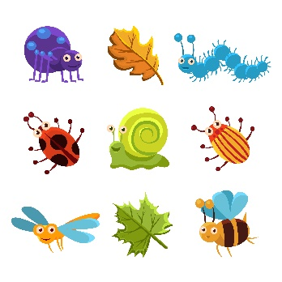

**July 28-Aug 1 – It’s A Bug’s Life** – The fun awaits this week as we discover a Big’s life! We will explore all things that crawl like the caterpillar, the ladybug, and things that fly from the bee to the butterfly. Your camper will learn the life cycle of an insect and even hatch butterflies from their cocoon. We will finish the week learning about gardening and the importance of some insects to the garden.

**LCLC Summer Camp Registration Form**

_________ Under the Big Top – June 16-20

_________Christmas in July – July 14-18

_________It’s a Bug’s Life – July 28-Aug 1

Name:_____________________________Age:______ Date of Birth:___________

Gender:__________Address:___________________________________________

Father’s Name:______________________________________________________

Address:___________________________________________________________

Email Address:______________________________________________________

Phone Number: (Work)_____________________ (Cell)_____________________

Mother’s Name:_____________________________________________________

Address:___________________________________________________________

Email Address:______________________________________________________

Phone Number: (Work)______________________ (Cell)____________________

Allergies/Health Issues:_______________________________________________

Special Needs/Considerations:_________________________________________

Individuals authorized to pick up your child and phone number:

______________________________________

______________________________________

______________________________________

In the event of an accident that requires immediate first aid or medical treatment at a time when a parent cannot be located, I give permission to Julie Allen, or other designated staff to authorize such treatment. I also authorize transfer of my child’s medical records if deemed necessary to the appropriate hospital. This is done with the understanding that every attempt has been made to contact the parents, the child’s physician, or other persons listed for emergency contact.

Parent Signature:____________________________________________________